Pharmaceutics

Question Bank for Chapter I: Ophthalmic dosage forms

1. Write a note on ocular bioavailability and limiting factors affecting corneal permeation
2. Enlist different types of ophthalmic dosage forms and describe any one in detail
3. What are the safety considerations of ophthalmic products
4. What are the ideal characteristics of an ophthalmic products
5. Discuss different methods of sterilization and justify which method will be suitable for which type of ophthalmic dosage form
6. Justify why it is necessary to adjust the pH and tonicity of ophthalmic products
7. Justify, why ophthalmic products are required to be sterile
8. What are the manufacturing area requirements of ophthalmic products
9. Write a short note on formulation and manufacturing techniques for :
   1. Ophthalmic solutions
   2. Ophthalmic suspensions
   3. Ophthalmic ointments
10. Write a short note on preservatives used in ophthalmic products.
11. What are the required properties of preservatives used in ophthalmic products?
12. Write a note on preservative efficacy testing
13. Give the significance of buffer capacity and role of buffers in ophthalmic product
14. Write a note on different additives / excipients / inactive ingredients used in ophthalmic products (solutions, suspensions, GFS, gels, ointments)
15. Write a note on packaging of ophthalmic products
16. QA & QC test of different ophthalmic products
17. Write a note on different type of contact lens care products
18. Write a note on different inactive ingredients used in contact lens care products

Pharmaceutics

Question Bank for Chapter II: Stability Testing

1. Define stability and discuss the need of performing stability studies
2. Classify different routes of degradation
3. What are the causes of hydrolysis reaction and methods to stabilize the drug susceptible to hydrolytic degradation
4. What are the causes of oxidation reaction? Methods of preventing oxidation of drug.
5. Classify different types of primary antioxidants and their mechanism of action.
6. Discuss Arrhenius Equation and describe the correlation between Arrhenius Equation and first order kinetics equation
7. Give the limitations of estimating shelf life using Arrhenius equation
8. Discuss how packaging material can help in improving stability of product.
9. Write a short note on ICH guidelines for performing stability study. Give the name of guidelines relevant for performing stability study
10. What is mean kinetic temperature and give the 4 climatic zones.
11. What do you mean by photostability study
12. What is stress stability study and what is the purpose of performing stress stability study
13. What do you mean by accelerated stability testing and give the importance of performing accelerated stability studies.
14. Give the conditions of long term, intermediate & accelerated testing and duration.
15. Give the protocol of stability study as per ICH guidelines
16. What do you mean by stability protocol and contents of the stability protocol?

Pharmaceutics

Question Bank for Chapter III: Sustained and Controlled Release systems

1. Define sustained and controlled release systems.
2. Give the limitations of conventional drug delivery systems
3. Give the advantage of controlled and sustained release systems.
4. Discuss drug factors that affect design of controlled and sustained release systems.
5. Give the importance of drug solubility, elimination half life, partition coefficient , dose size in design of sustained release dosage forms
6. Discuss absorption ,metabolism, distribution, elimination factors affecting design of sustained release products
7. Give the equations for calculation of dose (immediate & maintenance) for sustained release products.
8. Classify different types of design of sustained release dosage forms
9. Write a short note on reservoir / encapsulated type dissolution controlled system
10. Write a short note on matrix type dissolution controlled system
11. Write a short note on reservoir diffusion controlled system
12. Write a short note of matrix diffusion controlled system
13. Give Higuchi equation for matrix controlled systems and assumptions made in this equation.
14. Discuss in detail matrix systems for sustained release dosage forms
15. Discuss in detail reservoir systems for sustained release dosage forms
16. Write a short note on ion exchange controlled sustained drug delivery system.
17. Write a short note on osmotically controlled sustained drug delivery system.
18. Give comparison between matrix and reservoir sustained release system.
19. Give a short note on diffusion-dissolution controlled system.
20. Write a short note on bioerodible controlled matrix systems.

**Osmotically controlled Drug delivery System:**

In these systems drug is released at zero order rate based on principle of osmosis. Osmosis is natural movement of solvent through semi permeable membrane into a solution of higher solute concentration leading to equal concentration of solute on either side of the membrane.

* The system involves encapsulating osmotically active / inactive drug with an osmotically active salt ((Drug + NaCl) in a rigid semi permeable membrane (Cellulose acetate). A delivery orifice (hole) with controlled diameter is drilled using laser beam through the coating membrane.

Osmotic systems are of 2 types :

Type A contains a osmotic core i.e. drug along with osmotically active substance. This drug core is surrounded by semi permeable membrane drilled with hole

Type B contains the drug solution in a flexible bag, with the osmotic core surrounded by semi permeable membrane.

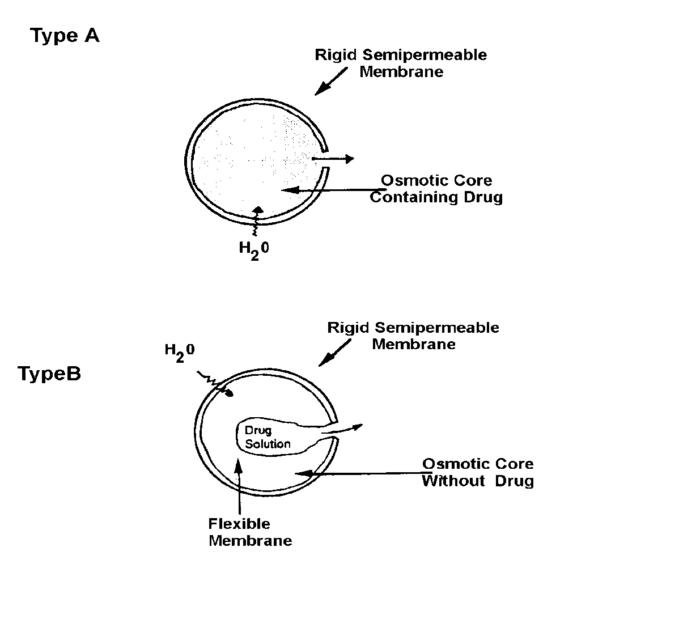

* Water is absorbed into the drug reservoir containing osmotically active salt. Water entering the dosage form dissolves osmotically active salt and as result osmotic pressure is created. Difference in osmotic pressure causes osmotic pressure gradient. This Osmotic pressure gradient pumps the drug out of the dosage form.
* **PPOP ( push pull osmotic system )**

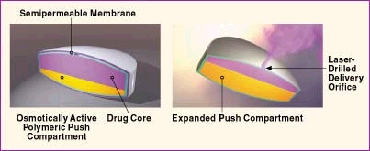

* They contain two or three compartment separated by elastic diaphragm
* Upper compartment contain drug with or without osmotically active salt (drug compartment nearly 60 – 80 %) and lower compartment (Push compartment) contain Osmotically active salt at 20 – 40 %.

Example ProcardiaXL for Nifedipine

* **Mechanism of Push Pull Osmotic System**

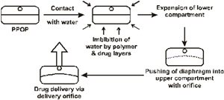

Pharmaceutics

Question Bank for Chapter II: Stability Testing

1. Define stability and discuss the need of performing stability studies
2. Classify different routes of degradation
3. What are the causes of hydrolysis reaction and methods to stabilize the drug susceptible to hydrolytic degradation
4. What are the causes of oxidation reaction? Methods of preventing oxidation of drug.
5. Classify different types of primary antioxidants and their mechanism of action.
6. Discuss Arrhenius Equation and describe the correlation between Arrhenius Equation and first order kinetics equation
7. Give the limitations of estimating shelf life using Arrhenius equation
8. Discuss how packaging material can help in improving stability of product.
9. Write a short note on ICH guidelines for performing stability study. Give the name of guidelines relevant for performing stability study
10. What is mean kinetic temperature and give the 4 climatic zones.
11. What do you mean by photostability study
12. What is stress stability study and what is the purpose of performing stress stability study
13. What do you mean by accelerated stability testing and give the importance of performing accelerated stability studies.
14. Give the conditions of long term, intermediate & accelerated testing and duration.
15. Give the protocol of stability study as per ICH guidelines
16. What do you mean by stability protocol and contents of the stability protocol.

Pharmaceutics

Question Bank for Chapter III: Sustained and Controlled Release systems

1. Define sustained and controlled release systems.
2. Give the limitations of conventional drug delivery systems
3. Give the advantage of controlled and sustained release systems.
4. Discuss drug factors that affect design of controlled and sustained release systems.
5. Give the importance of drug solubility, elimination half life, partition coefficient in design of sustained release dosage forms
6. Give the equations for calculation of dose (immediate & maintenance) for sustained release products.